**User Guide:**

Mobile Data Collection with KoBo Toolbox

Authors: Jin Rou (JR) New and Chi Zhang

Last updated: 22 November 2014

KoBo Toolbox is a suite of tools for field data collection.

1. Sign up for an account at KoBo Toolbox. Use the *Sign Up* button on the left.

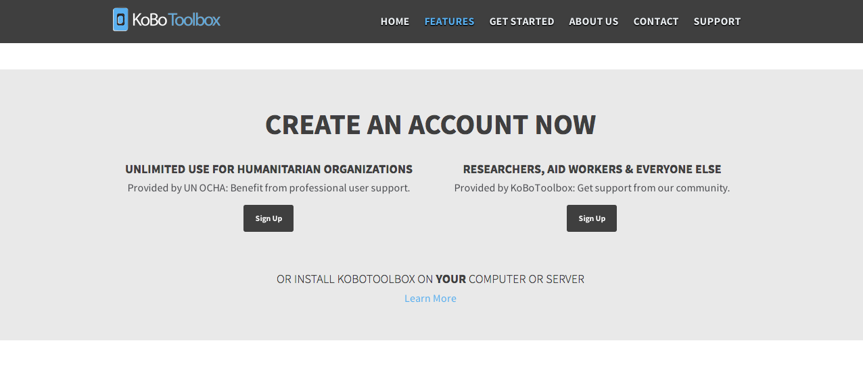

2. Create a new form.

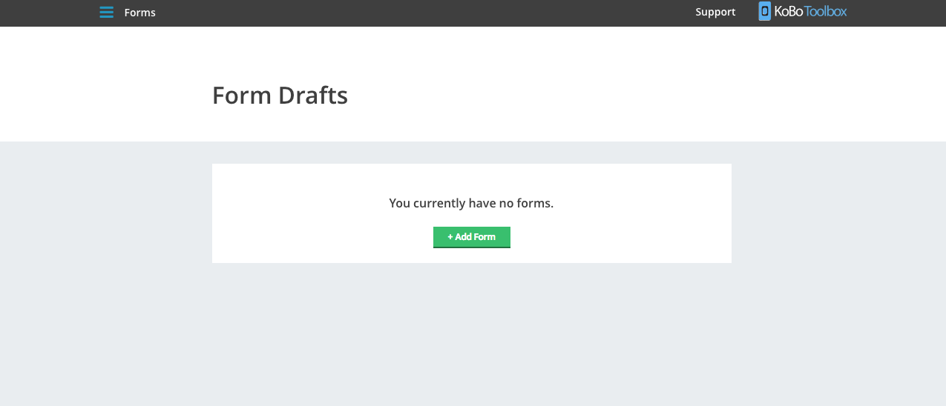

2a. Method 1: Use the intuitive web interface to create your form.

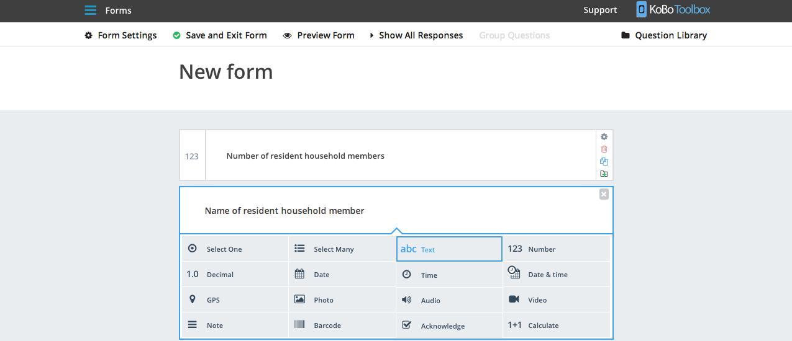

2b. Method 2: Create the form in an Excel spreadsheet and upload.

* See detailed guide on using XLSForm at <http://xlsform.org/>
* See example in folder at hhquestionnaire/hhquestionnaire.xls.

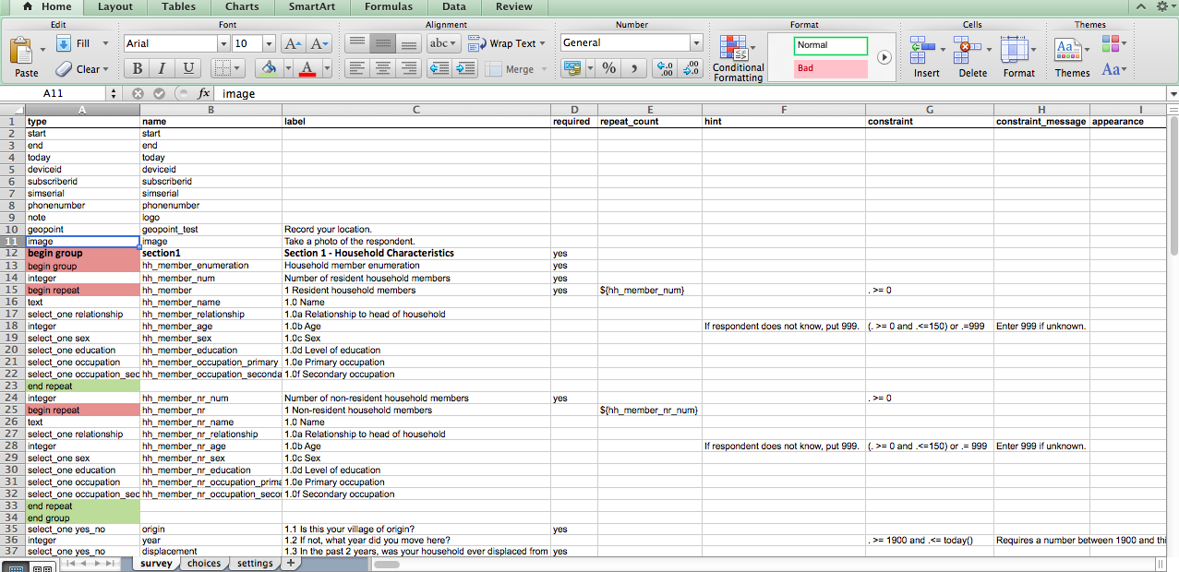

3. Deploy your survey project.

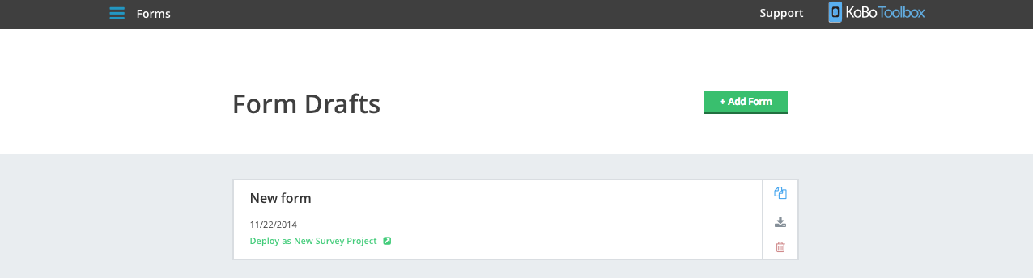

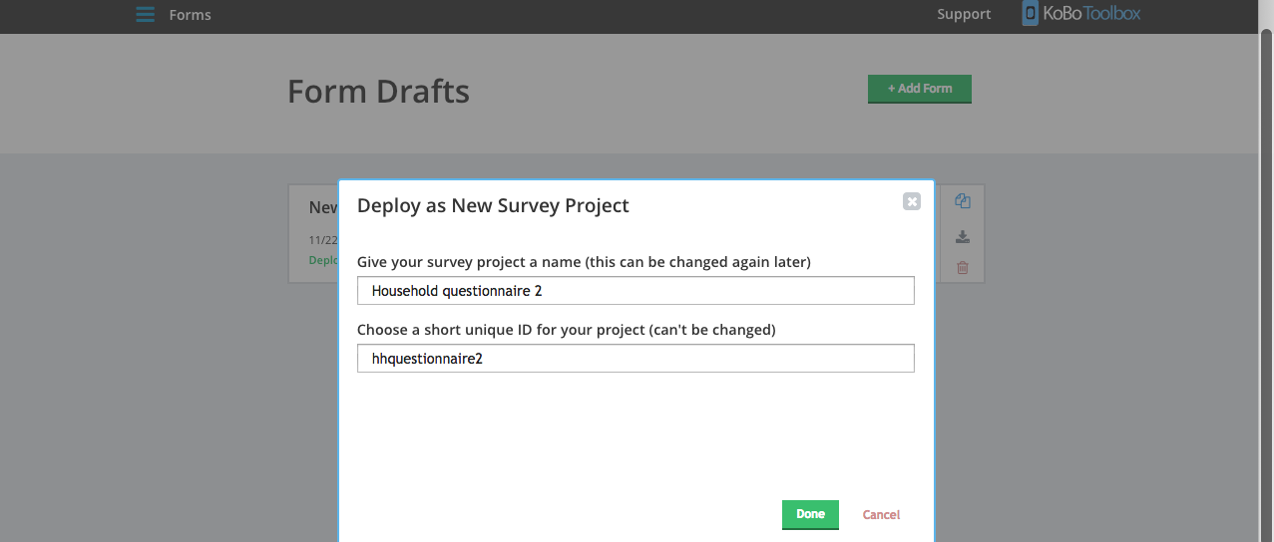

4. Monitor form submissions and manage users on the project page. Analyze data on the web interface or download data for offline analysis.

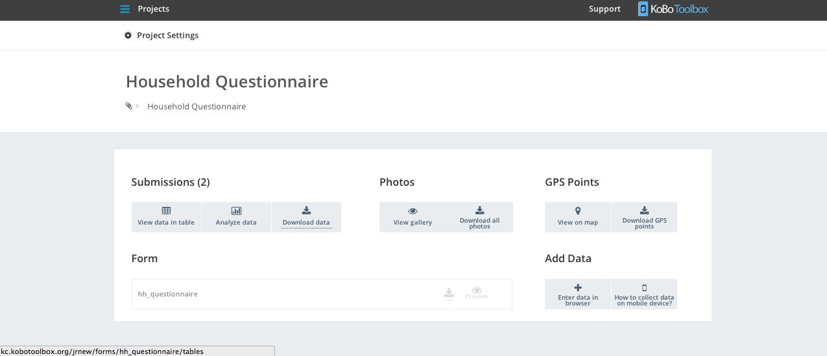

5. On the data collector side, download the Kobo Collect Android app from the Google Play Store. Modify general settings and change the URL to your account. Manage the admin settings (e.g. toggle settings visible to the data collector). The data collector can now start collecting data!